1.55: In Eq. (1.27), the only non-vanishing component of the cross product is

so 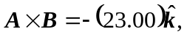 and the magnitude of the vector product is 23.00.

